LESSON THREE 混合图和流程图练习

混合图练习：

一. 请运用课上知识，完成全篇写作。
The table and graph below show the cinema visits in Australia between 1994 and 2004.
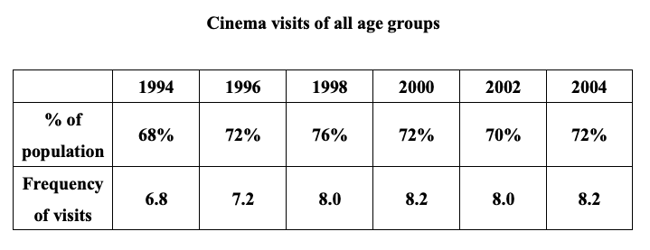
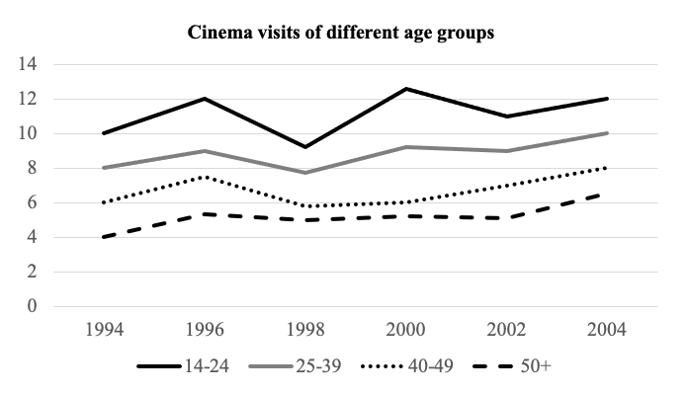

流程图练习：

一. 请写出一下意思的英文单词或词组(有多个单词选择的，正确即可)
- 碾磨
- 原材料
- 清洗
- 过滤
- 倾倒
- 粉碎
- 包含
- 分类
- 运输
- 混合物

二. 请把下面句子翻译成英文。
1. 这个图展示了巧克力的制作过程。

2. 总的来说，纸张的制作过程较为复杂，共有八步。

3. 首先，原材料被运输到工厂。

4. 下一步是把浆糊倾倒到一个机器中。

5. 最后一步把这个材料碾磨成粉末。

二. 请用课上所学，完成以下流程图写作。
You should spend about 20 minutes on this task.
The diagram below shows how soft cheese is made.
Summarise the information by selecting and reporting the main features and make comparisons where relevant.
Write at least 150 words.
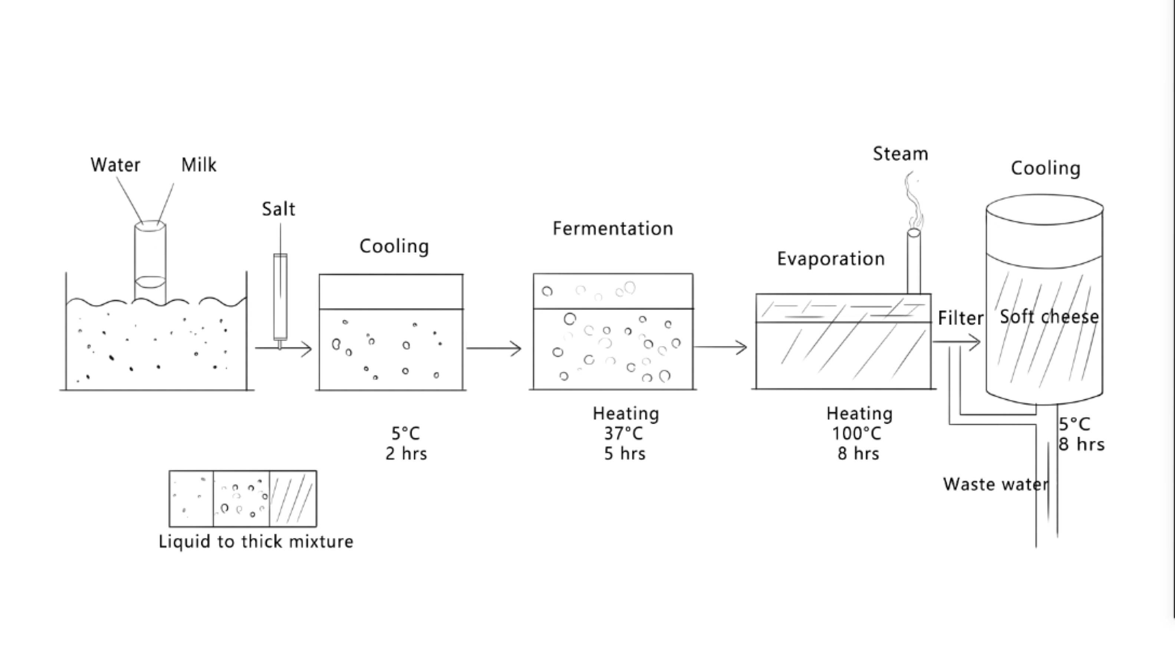

Answer Key
一、
- 碾磨 grind
- 原材料 raw material
- 清洗 clean/ rinse/ wash
- 过滤 filter
- 倾倒 pour
- 粉碎 smash
- 包含 entail
- 分类 classify/ categorize
- 运输 deliver/ transport
- 混合物 mixture

二、
1. The diagram illustrates the process of chocolate-making.
2. To summarize, the whole process of making paper is rather complex, which entails eight major stages.
3. First of all, raw materials are transported to a factory.
4. The next stage is to pour the paste into a machine.
5. The final stage is to grind the material into powder.

混合图参考范文：
The table illustrates changes in the percentage of the Australian population who visited cinemas over a ten-year period, as well as the frequency of visits. The line graph shows how the cinema visits of four particular age groups changed over the same time period.

Looking at the table first, it is evident that from 1994 to 1998, there was a gradual increase in the percentage of the population who visited cinemas from 68% to 76%. After that, there was a drop to 70% in 2002. Finally, the percentage rose again back to 72% in 2004. There was a corresponding increase in frequency of visits from 6.8 in 1994 to 8.2 in 2000. Then, the frequency saw a similar trend. It fell to 8.0 and rose again back to 8.2 in 2004.
Moving on to the line graph, it is clear that the frequency of 14-24 age group fluctuated between 10 visits a year and 12 visits. Similarly, the frequency of 25-39 age group fluctuated between 8 visits a year and 10 visits a year. The frequency of the 40-49 age group rose from 6 visits to 8 visits, and the frequency of the over-50 age group increased from 4 visits to 6.1 visits.

In general, the percentage of population who went to cinema rose and then fell. The frequency of the four age groups also rose, but there were some falls.

流程图参考范文：
The diagram illustrates the process of soft cheese-making.

Overall, it is clear that the process of producing soft cheese is not very complex, which entails only five major stages. The whole process begins with mixing water and milk and ends with cooling the cheese.

First of all, water and milk, the raw materials, are poured into a tube and the liquid is in a container. After that, salt is added into the mixture. Gradually, the mixture becomes thick. The mixture is cooled at 5ºC for two hours. The following stage is to put the cold mixture into a container. The mixture is then heated at 37ºC. The fermentation process lasts for five hours. After that, the mixture is heated again at 100ºC for eight hours. The steam evaporates during the stage. The next stage is to filter the mixture, so that the waste water is removed. Finally, the final stage is to cool the soft cheese at 5ºC for eight hours, and again, waste water is removed.
167 words

